# 

The Spirit of the Lord GOD is upon me; because the LORD hath anointed me to preach good tidings unto the meek; he hath sent me to bind up the brokenhearted, to proclaim liberty to the captives, and the opening of the prison to them that are bound; (Isa 61:1)

Liberty Behind Bars

|  |  |  |
| --- | --- | --- |
| **Dale Morey** | **5/15/2016** | **Black Creek Baptist Church** |

**The Beginning**

O

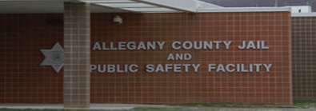ver the summer, Amy and I took the class that would certify us to enter in the Allegany County Jail and minister to the inmates. Our first scheduled visit was in January, 2016. We did not know what to expect, but allowed the Lord to lead us. Our first visit had 5 inmates who attended. I was able to give my testimony and a short message to them. They seemed to enjoy the visit and had many questions. One inmate in particular took a liking to me and asked if I could research a topic and send him a letter in the mail, which I did. I returned the following Sunday and the same individuals were present. We explained that we were on a rotation and would not be able to come back until April. When April came, I returned to find out that no other church had been coming. That day I was able to go into a different section (pod) and talk to a different group of men. The visit went well but they confirmed that no one has been coming each week for a church/bible study. The Lord laid on my heart the importance of showing up each and every Sunday to see if I would be able to get in. The Lord has opened up the door in that He has made it possible for me to go in every week for the past month. Last week I went and was informed by a correctional officer that I was allowed to visit different pods instead of just choosing one a week. This opened a whole new door for me as now I will be able to see more inmates. During my last visit there were 20 people that I was able to give a message to. This is a tremendous increase since I began and I owe it all to the Lord Jesus.

**Praises**

W

e’ve had many blessings as our ministry grows. Knowing our church family and others praying for us has been so important to us. A couple individuals have helped with financial burde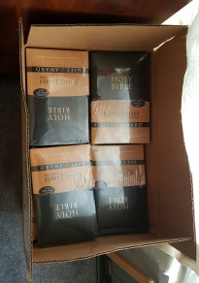ns as well; which is such a blessing. A family in our church was led to order two cases of King James Bibles to be given to inmates who needed them. It is so exciting to have people work with us in reaching these individuals behind bars. The Lord is starting to send people who are interested in going into the jail with me. I am in the process of getting the information for a gentleman who wants to take the course and start coming with me on a weekly basis. Please pray that the course is offered soon. Also, I have a friend who is a retired sheriff that is also interested in ministering to the inmates with me. What a blessing to know that the Lord is making friendships between me (an ex-convict) and those who are serve the law (sheriffs, cops, and others in authority) to work in the ministry teaching about the saving grace of the Lord Jesus Christ!

**Prayer Requests**

W

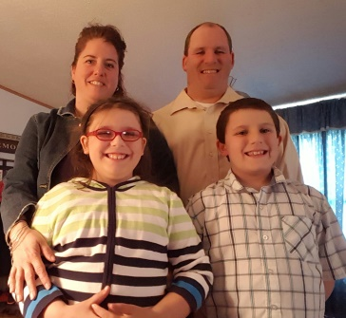e are asking prayer that the Lord keeps the door open so I can go into the jail every week. These inmates are hungry to hear the Word of God and look forward to it every Sunday. Pray for the inmates at the Allegany County Belmont Jail as well. There are many young men who have gotten caught up with the drug epidemic (using and selling) and profess that they want out of this life-style. Pray for the ladies also. Many are mothers, wives, addicts who feel alone and rejected by everyone. Please also pray for the needs of the ministry are met. I would also like to branch out to other local jails and prisons. Please pray that I have wisdom to know when it is time to move in this direction. Due to the many hours spent in preparing for the ministry, prayer for my family is also always appreciated.

Amy, Dale, Autumn, and Luke

Your servant in Christ



**Thank you for praying!**