# 

The Spirit of the Lord GOD is upon me; because the LORD hath anointed me to preach good tidings unto the meek; he hath sent me to bind up the brokenhearted, to proclaim liberty to the captives, and the opening of the prison to them that are bound; (Isa 61:1)

Liberty Behind Bars

|  |  |  |
| --- | --- | --- |
| **Dale Morey** | **9/25/2016** | **Black Creek Baptist Church** |

I

was blessed to be able to get into a local WNY prison to visit an inmate this month. We had a great time in the Lord. Please pray for him (I'm keeping name anonymous). The prison was right next door to the prison that I spent 3 of the 5 years at. This brought back a lot of memories, but I thank God for where I am today. *But by the grace of God I am what I am (1Co 15:10)*. I was also able to get into the Allegany County Jail three weeks in a row. It has been difficult because of the inmate turn-over rate. In jail, some inmates stay anywhere from a couple days to up to a year, or are transferred to prison due to their sentencing. I have also been in contact with a few out of state inmates who have recently started writing me (from as far away as California). I have also been blessed to be able to preach at my home church at Black Creek Baptist Church. I preached on “Getting back to the basics - checking your foundation; part 1.” I will be preaching part 2 this Sunday at the 1pm service.

**Praises**

W

e have been able to mail in KJV bibles that were donated to the ministry to individual inmates. So far 8 of these bibles are in the hands of inmates that I get to preach to in the Allegany jail. This is a big step because jail administration often gives a hard time allowing bibles in. Another praise is that our home church has started supporting our ministry on a monthly basis! We are in the works of putting together a missionary board, prayer cards, etc. We also praise God for an individual who donated a professional tri-fold missionary presentation board

**Prayer Requests**

P

ray for my next prison visit that will be at a prison called Mid-State which is down in Marcy, New York. Also, I have made another attempt to contact Allegany County administration with regards to coming in on a weekly basis. So far, I have had no response.

Please keep my recovery (back surgery) in prayer. Pray that I would be able to get into the jail on Sundays.

Continue to pray for the salvation of the inmates and guards. College is going well, continue to pray that not only I retain the information that I am learning, but also to put what I am learning into practice.

*Now no chastening for the present seemeth to be joyous, but grievous: nevertheless afterward it yieldeth the peaceable fruit of righteousness unto them which are exercised thereby. (Heb 12:6-11)*

Keep our family in prayer spiritually, physically and financially.

Please pray that the Lord opens doors in other area jails and prisons that I may come in. Also, the doors are open to other churches in which I can present this ministry.

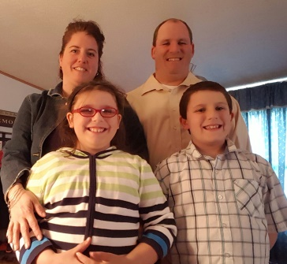Again thank you for all of your prayers!

Your servant in Christ

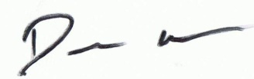

Amy, Dale, Autumn, and Luke

**Thank you for praying!**