# 

The Spirit of the Lord GOD is upon me; because the LORD hath anointed me to preach good tidings unto the meek; he hath sent me to bind up the brokenhearted, to proclaim liberty to the captives, and the opening of the prison to them that are bound; (Isa 61:1)

Liberty Behind Bars

|  |  |  |
| --- | --- | --- |
| **Dale Morey** | **7/31/2016** | **Black Creek Baptist Church** |

I

continued to go to the Allegany Jail during June and most of July in hopes that no other church would come. Unfortunately, we have hit a few roadblocks. Every Sunday in July, there has been someone from different churches that have been coming in to speak to the inmates. Thus, I was not able to get in. On my scheduled day to have a church service, none of the inmates called out that they were interested in attending. This was disheartening, as 2 months ago 10-15 inmates were faithfully coming to the service. Due to my back surgery I will not be able to make my next scheduled visit. If churches do continue to come, I may not be able to get back in until December.

**Praises**

O

ne of the inmates that was released in the middle of June contacted me. He was thankful for meeting me and seems to staying on track. He was able to secure employment and has been reading his bible.

I had my back surgery on July 20th and the doctor seems to be very optimistic that I will be in less pain. He fused three vertebrae and added additional hardware to secure the fusion. He also used a state of the art robot to assist in the surgery. He was very pleased and looks forward to seeing the results in a couple months. Personally, I feel this surgery has been successful, as I am able to maneuver easier and am in less pain – only a week or so after the surgery! To God be the Glory!

After 3 weeks after our automobile accident, we finally got our car back! God worked wondrously during this time as we just trusted him to take care of everything. His mercy and grace showed through this trial. Praise God!

**Prayer Requests**

I

have made several calls to the appropriate supervisors to see if I can come on a weekly basis (on a day other than Sunday) and get King James Bibles into the reading carts of the different Pods. Unfortunately, I have not had any return phone calls. Please keep this in prayer.

Please keep my recovery in prayer. I am praying that this surgery will be my last and that the pain will be considerably lower. Please also pray that there is bone growth, as this was one of the major reasons why my previous surgery failed. I will be out of work for the next 12 weeks, so please pray that the Lord provides our daily bread.

Pray that I would be able to get into the jail on Sundays.

Continue to pray for the salvation of the inmates and guards. College is going well, but continue to pray because there is a lot of material to know.

*Now no chastening for the present seemeth to be joyous, but grievous: nevertheless afterward it yieldeth the peaceable fruit of righteousness unto them which are exercised thereby. (Heb 12:6-11)*

Please pray that the Lord opens doors in other area jails and prisons that I may come in. Also, the doors are open to other churches in which I can present this ministry.

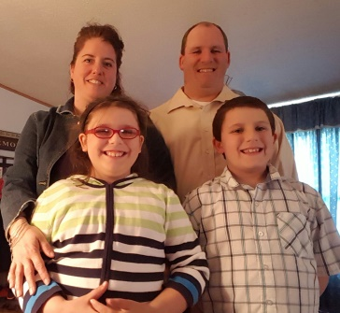Again thank you for all of your prayers!

Your servant in Christ

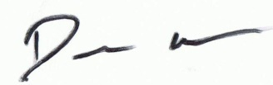

Amy, Dale, Autumn, and Luke

**Thank you for praying!**