

**Liberty Behind Bars Ministry**

**A Ministry of Black Creek Baptist Church**

**July, 2017**

S

pring has come and gone so quickly this year! I can’t believe it is almost the middle of July already! Since our last newsletter the Lord has been doing some amazing things! The Lord is always amazing, but it is so neat to see things happen right in front of your eyes.

*The Spirit of the Lord GOD is upon me; because the LORD hath anointed me to preach good tidings unto the meek; he hath sent me to bind up the brokenhearted, to proclaim liberty to the captives, and the opening of the prison to them that are bound;*

*(Isa 61:1)*

The Lord has greatly helped me with my graduate studies (Biblical Counseling). I have one course to finish and I believe that I will complete it by the end of August, 2017. If the Lord allows, I will start on my doctorate studies in the fall. Many ask, “Why do you need a Doctorate?” I am not getting a doctorate for notoriety. As many of you know my life’s testimony is riddled with jail/prison time. In the world’s eye – my credibility is very low. Handing a prison my credentials will look much more favorably and will undoubtedly allow me to get into more local, state, and federal prisons (whether locally or nationwide).

Amy and the kids are done with school! Hallelujah! We long for this time as a family to re-group, re-fresh, and “prune” our vineyard. It is very difficult to send our children to public school and we long for the day where Amy can homeschool our children. Please keep this in prayer for our family!

With the Lord’s guidance, Pastor Cacciola (Anchor Baptist Church) and I have been able to get into the Allegany County Jail more frequently since my last letter. Amy also had the opportunity to meet with the ladies to give her testimony. There were many tears shed from both sides – to God be all the glory!

I have had the opportunity to visit a few different inmates and meet with their families. This has been a blessing on both sides. It’s humbling yet rewarding to see what God is doing in these individuals.

**Praises**

It has been so heart-warming to see how many children support our ministry! We have had countless children save their money and donate towards stamps, letters, and bibles. I bring my “baggie” of change to the post office and witness to the workers where the money came from and what it is being used for. They are stunned when they hear what our little ones have contributed! Praise God for their cheerful giving!

The bi-weekly devotionals have been a great success. Currently we have close to 15 inmates who request a copy mailed to them. We have received many letters from inmates these past couple months as well. Letters of hope, letters of changes, letters of encouragement from a variety of inmates. Yes, many are still searching but it is amazing to see God work in their hearts!

This is a praise and a prayer request…we are almost out of KJV bibles! I have been able to send in bibles to many inmates. During Sunday services, it is awesome to see them holding and reading from the true Word of God!

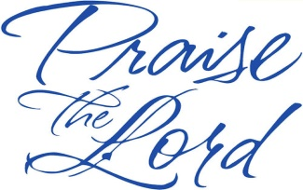Just this week, due to diligence and Pastor Cacciola’s connections, we were given the green light to hold a weekly (Thursday night) 2 hour bible study. We have been praying for this for close to a year as I am technically only scheduled 8 Sundays for the entire year! I continue to sit in the parking lot and have the opportunity to go in when scheduled churches do not attend – Glory to God for that!

**Prayer Requests**



I have been asked to travel down south to preach in various churches. I am hoping that I will also be able to present the ministry. Please pray that the Lord give me wisdom, discernment, and safe travels.

Please pray for Shantal and Maraida – these two women inmates are being sentenced within the week and will be transferred to prison. They are very nervous but have stated they trust the Lord with whatever decision is made. Pray they keep in contact with LBB as well.

Pray the Lord continue to guide my thoughts on the bi-weekly devotional that is sent to the inmates.

Continue to pray for the safety and salvation of the inmates and guards, and their families. Keep our family in prayer for spiritual, physical and financial needs.

*Now no chastening for the present seemeth to be joyous, but grievous: nevertheless afterward it yieldeth the peaceable fruit of righteousness unto them which are exercised thereby. (Heb 12:6-11)*

Please pray that the Lord opens doors in other area jails and prisons that I may come in. Also, the doors are open to other local churches in which I can present this ministry.

**Specific Needs:**

* stamps
* 9x12 envelopes (to send bibles to inmates)
* regular legal size envelopes (sending monthly “devotional study in the mail” to inmates)
* printing paper
* King James Bibles

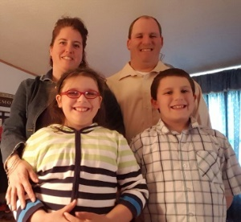If anyone would like to make a donation to Liberty Behind Bars, please make checks payable to Black Creek Baptist Church c/o Liberty Behind Bars (in memo part of the check).

Many blessing to you all! Again thank you for all of your prayers!

Your servant in Christ

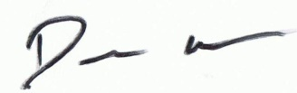

Amy, Dale, Autumn, and Luke

**Thank you for your support and prayers!**